**IMPLEMENTING CRM FOR RESULT TRACKING OF A CANDIDATE WITH INTERNAL MARKS**

**1 INTRODUCTION**

* 1. **Overview**

**Administrator should be able to create all base data including Semester, Candidate, Course and Lecturer, Lecturer should have the ability to create Internal Results, Dean, who is one of the Lecturer, should be the only one with ability to update Internal Results, Re-evaluation Can be initialized by Candidate for all Internal Results. Now only dean can update the marks after re-evaluation.**

* 1. **Purpose**

**It is save a lot of time. The purpose of the project is to manage the school student's result tracking process in the easy way. Student do not need to check the notice board and everyone will stay updated this is the main purpose of the project. Can work easily. Increase candidate quality.**

**2 PROBLEM DEFINITION&DESIGN THINKING**

**2.1 Empathy Map**

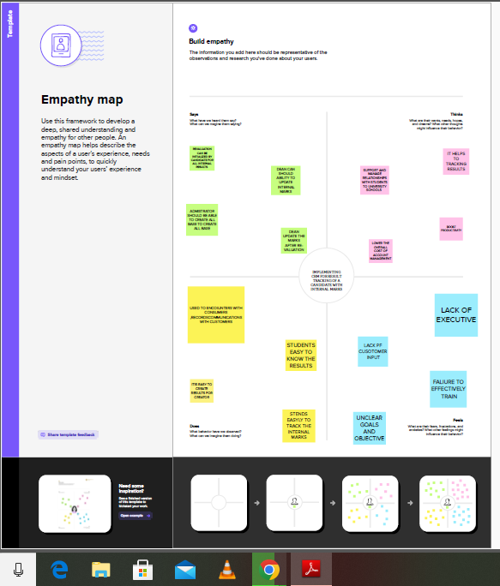

**2.2 Ideation and Brainstorming Map**

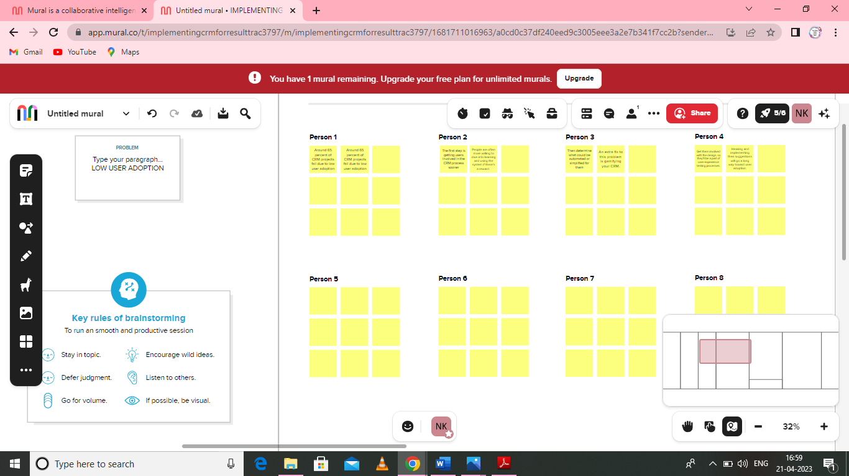

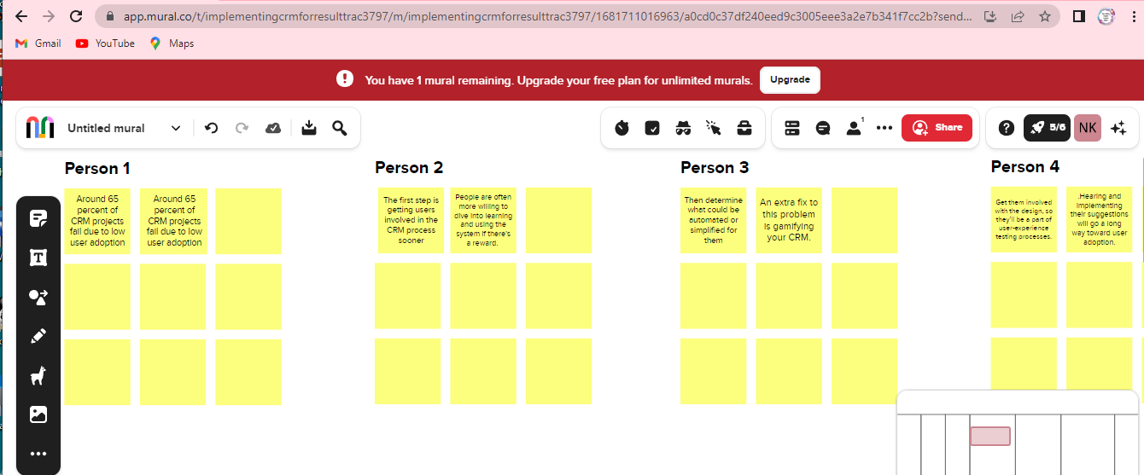

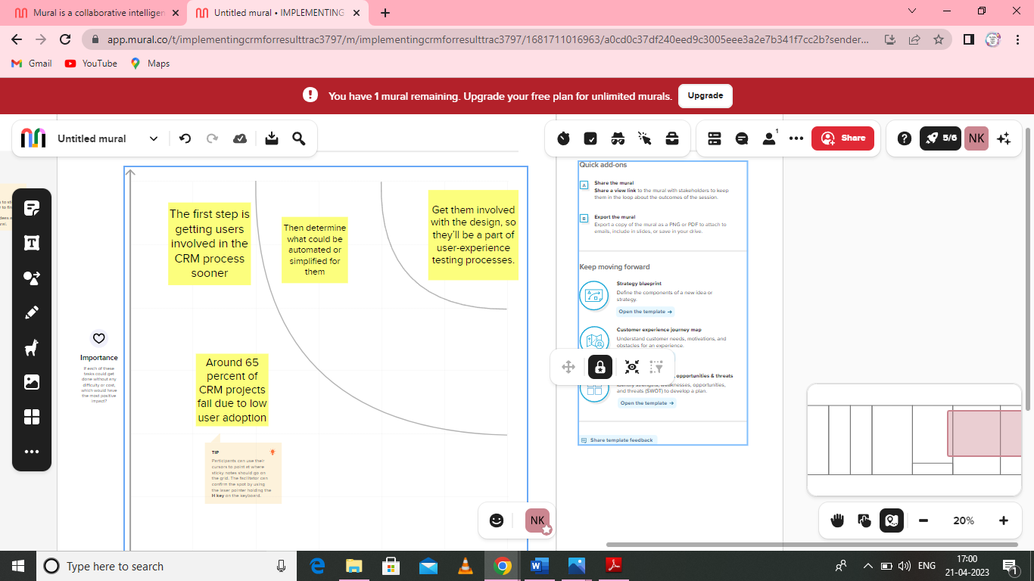

**3 RESULT**

**3.1 DATA MODEL:**

|  |  |
| --- | --- |
| **OBJECT NAME** | **FIELDS IN THE OBJECT** |
| **SEMESTER** | |  |  | | --- | --- | | **Field label** | **Data type** | | Semester name couse (look up) | Text | |  |  | |
| **CANDIDATE** | |  |  | | --- | --- | | **Field label** | **Data type** | | Candidate name | Text | | Canditate ID |  | | Semester name |  | | Internal results (lookup) |  | |
| **COURSE DETAILS** | |  |  | | --- | --- | | **Field label** | **Data type** | | Course name | Text | | Course ID |  | |
| **LECTURER DETAILS** | |  |  | | --- | --- | | **Field label** | **Data type** | | Lecturer role | text | | Lecturer name |  | | Course ID |  | | Course (look up) |  | |
| **INTERNAL RESULTS** | |  |  | | --- | --- | | **Field label** | **Data type** | | Candidate ID | Text | | Course ID |  | | Marks |  | |

**3.2 Activity& Screenshot:**

**Milestone 1: Creation Saleforce**

**Activity 1:**

**Creating Developer account**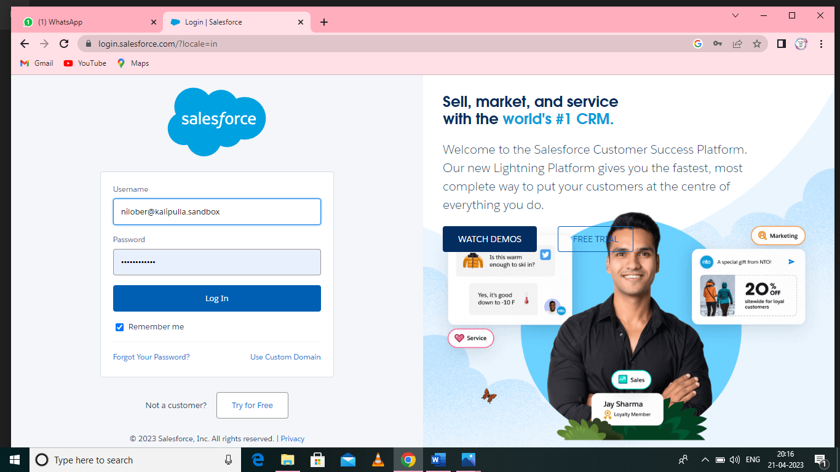

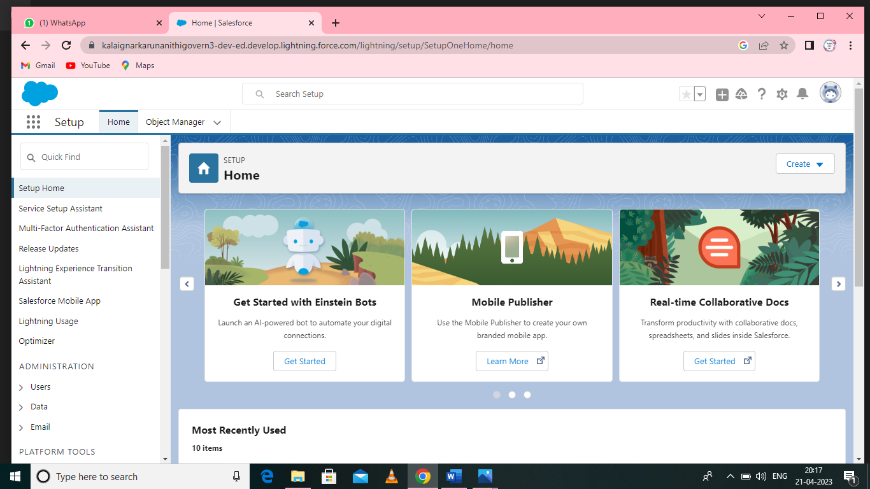

**Milestone 2 : Object**

Salesforce objects are database tables that permit you to store data that is specific to an

organisation. Salesforce objectsare of two types: Standard Objects: Standard objectsare the

kind of objects that are provided by salesforce.com such as users, contracts, reports**,**

dashboards, etc.

**Custom Objects:**

**Activity1:**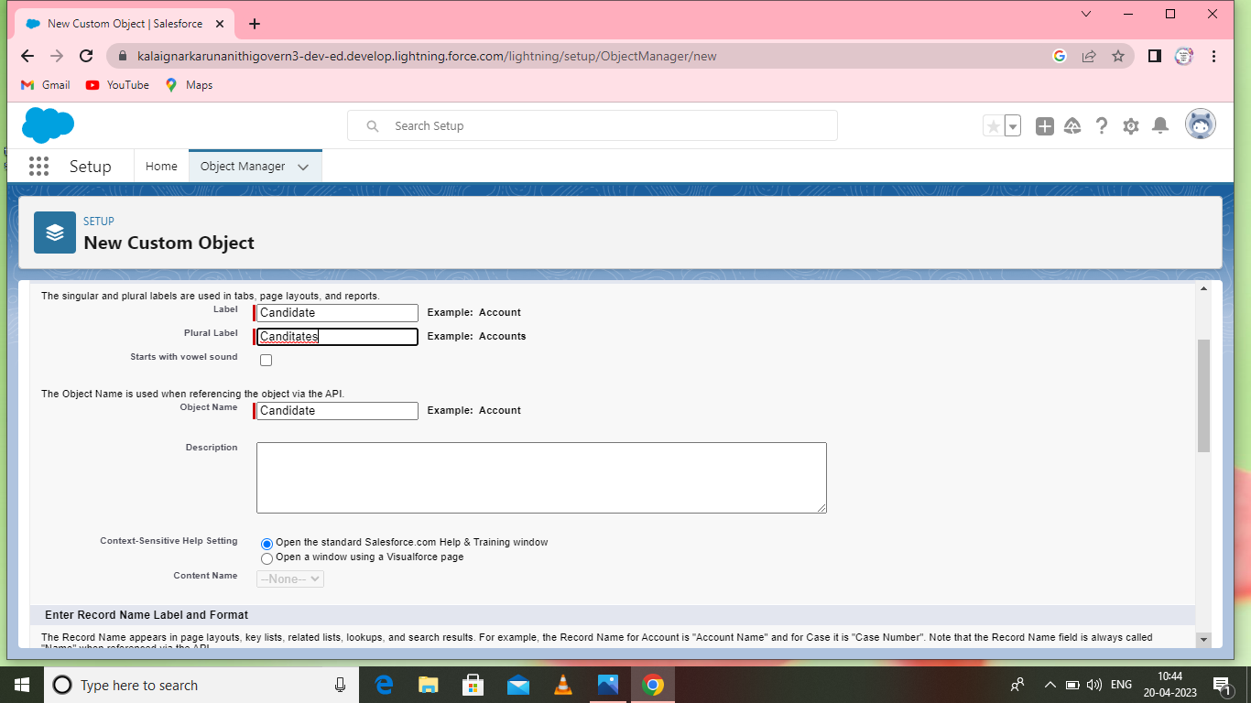

Enter the label name, click on allow reports ,allow search then save.

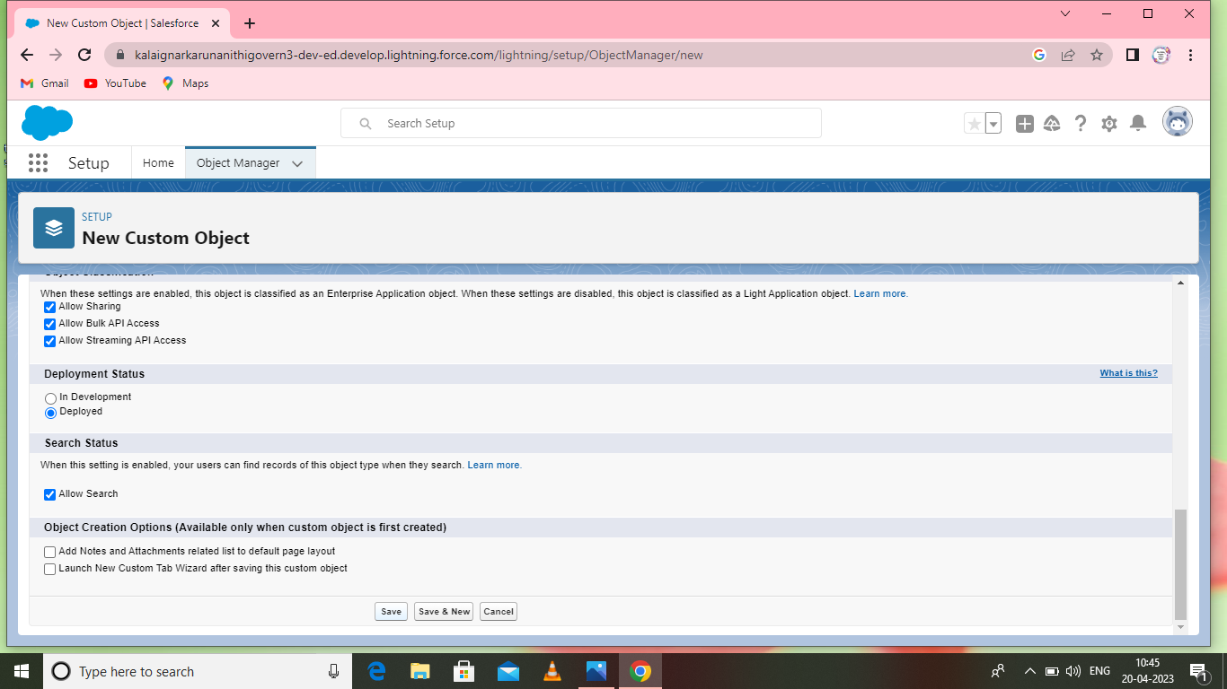

**Activity2:**

Follow similar steps to create candidate , course details, lecturers details , internal results objects.

**Milestone2: Fields & Relationship**

An object relationship in Salesforce is a two-way association between two objects.

Relationships are created by creating custom relationship fields on an object. This is done so

that when users view records, they can also see and access related data.

**Activity 1 :**

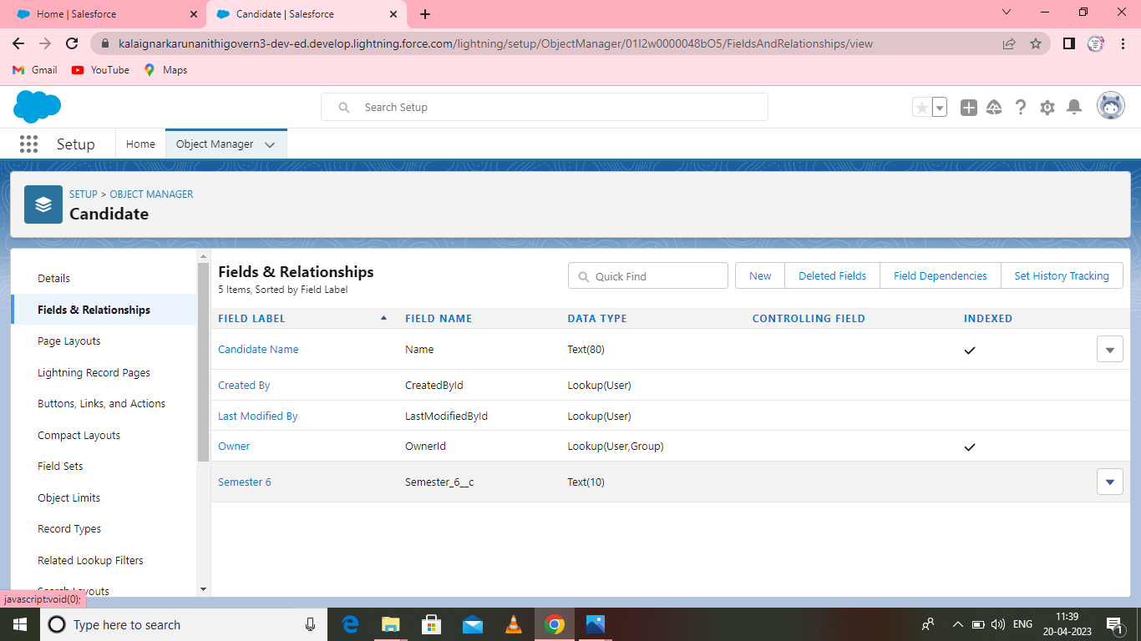

Go to setup-click on object manager-type object name in search bar-click on the object.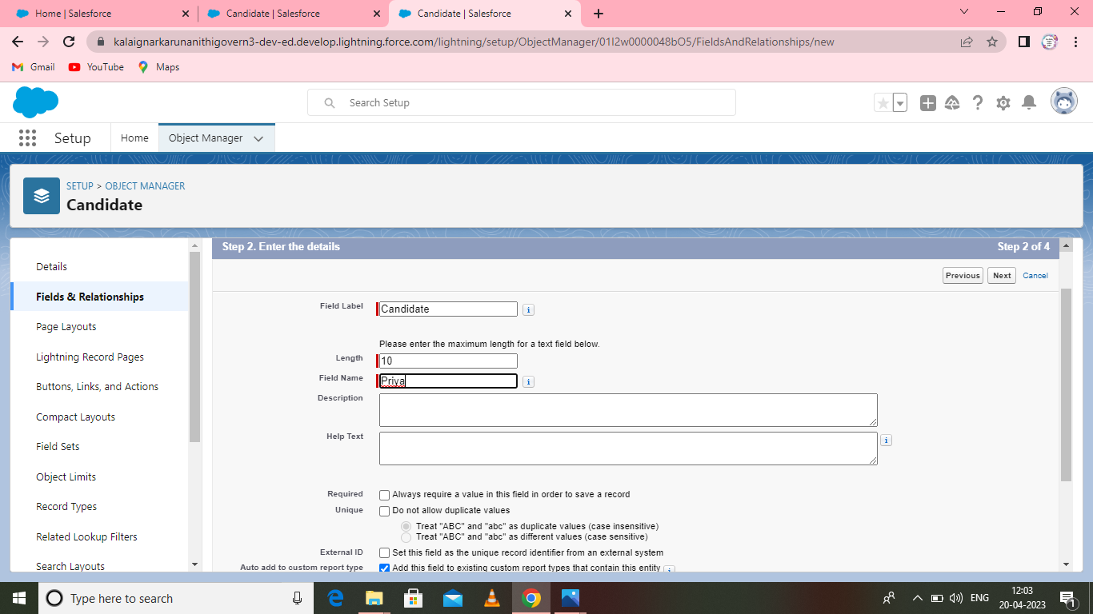

**Activity 2:**

Similiarly create semester , candidate ,course details ,lecturer details, internal results.

**Milestone 3:Lightning App**

Apps in Salesforce are a group of tabs that help the application function by working together

as a unit. It has a name, a logo, and a particular set of tabs. The simplest app usually has just

two tabs

**Activity1:**

**Create the candidate Internal Result Card app:**

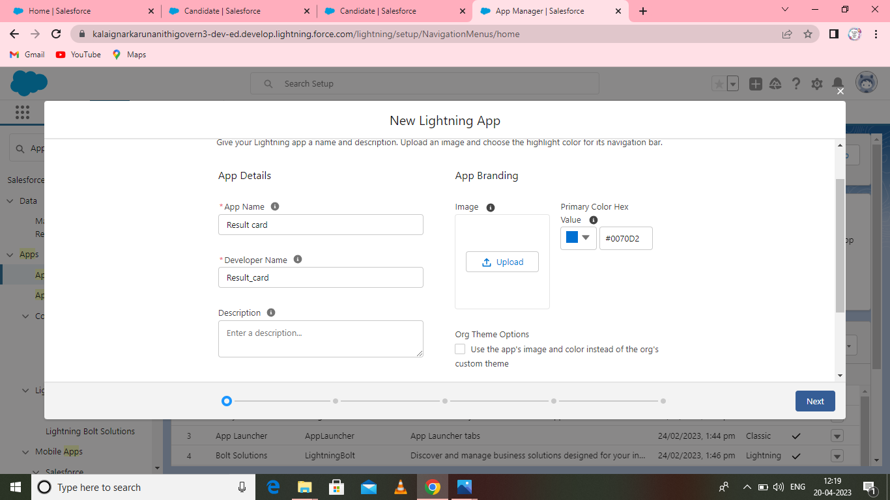

Go to setup page- search app manager in quick find -select app manager- click on new lightning app.

**To add navigation items:**

Select the items from the search bar and move it using the arrow button-next.

Search profiles in search bar-click on the arrow botton-save finish.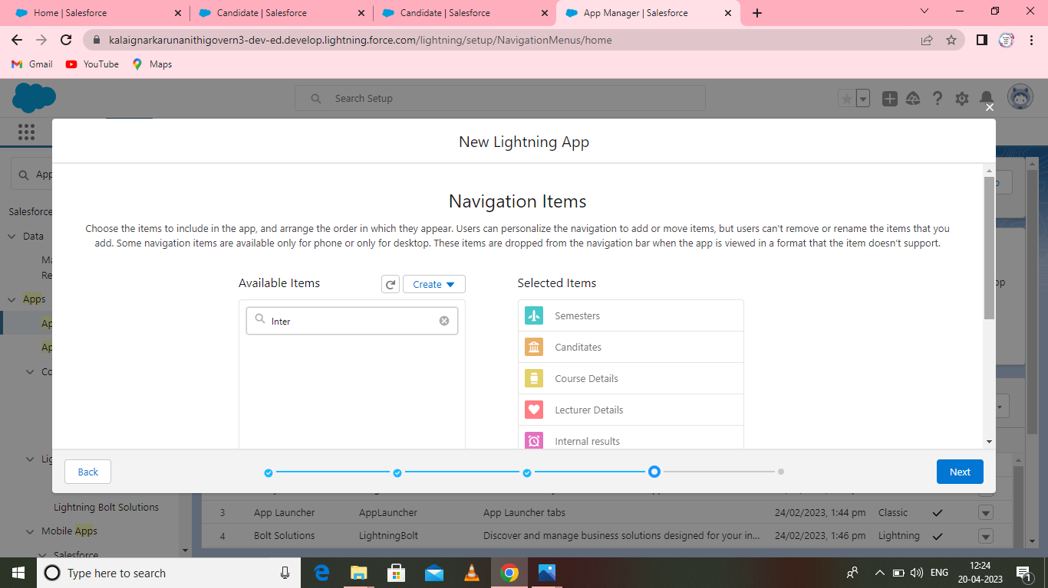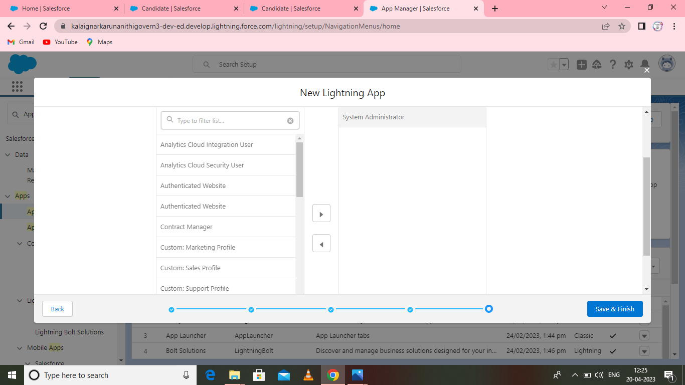

**Milestone 4: Users**

A user is anyone who logs in to Salesforce. Users are employees at your company,

such as sales reps, managers, and IT specialists, who need access to the

company's records. Every user in Salesforce has a user account.

**Activity 1:**

Creating a users.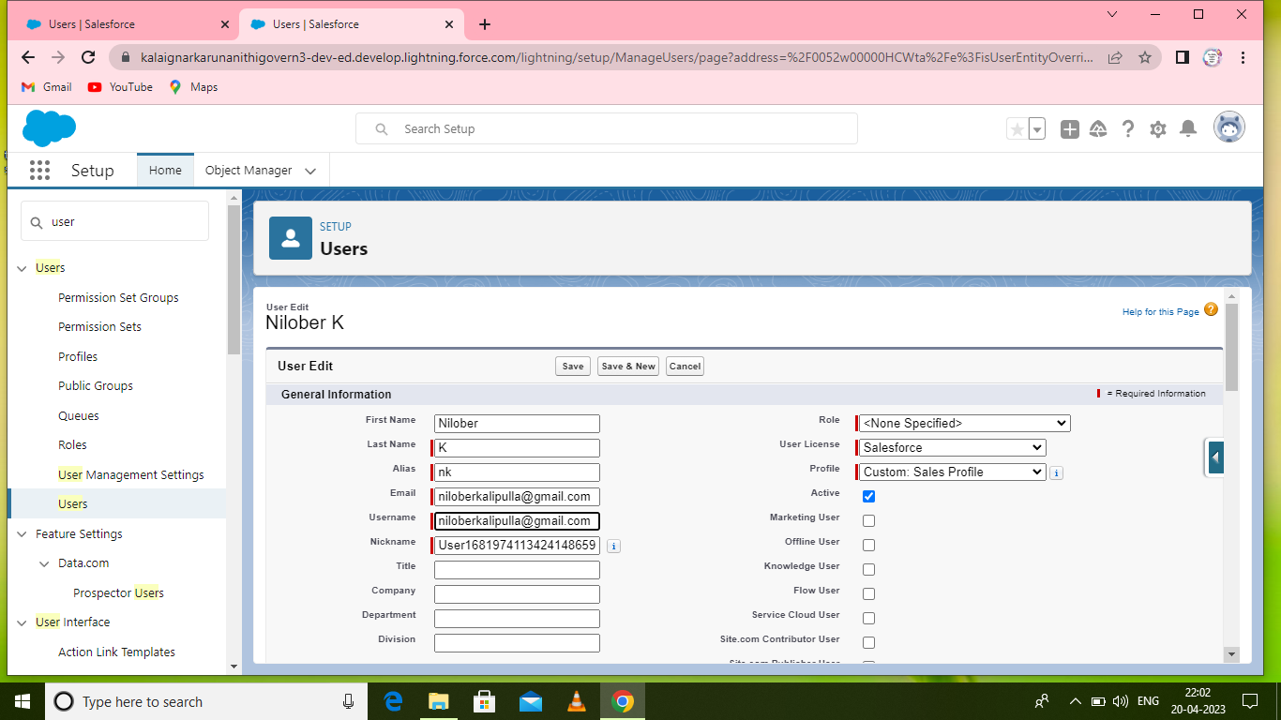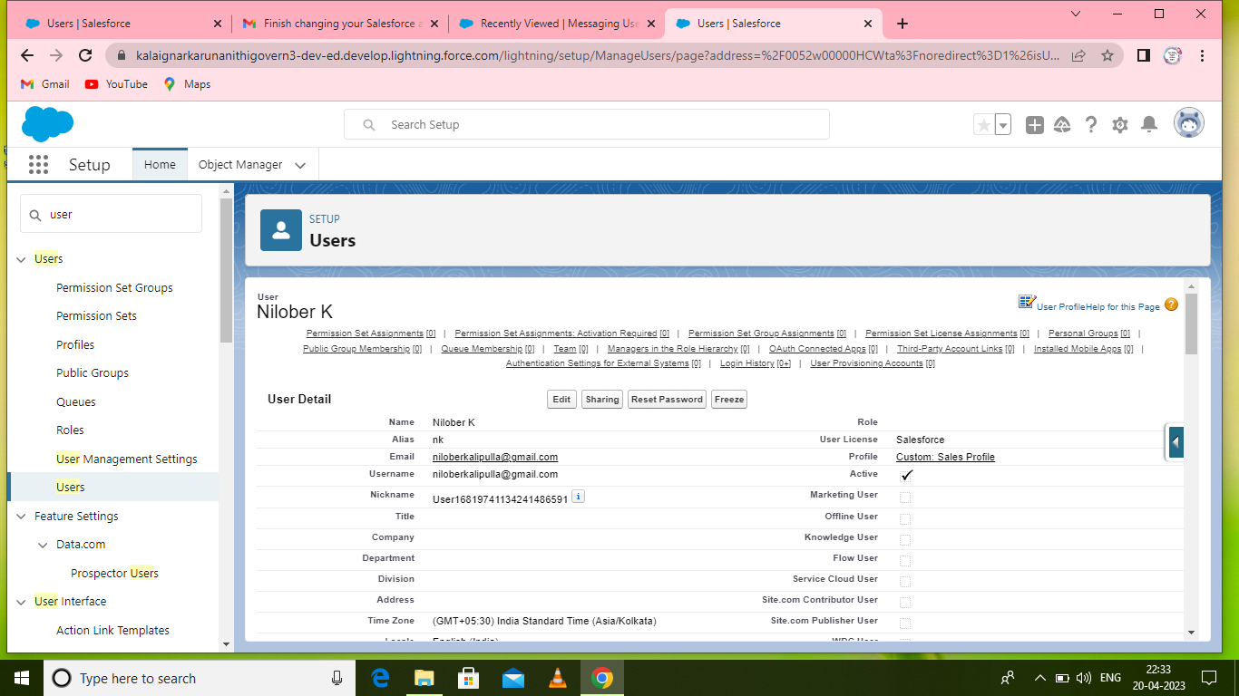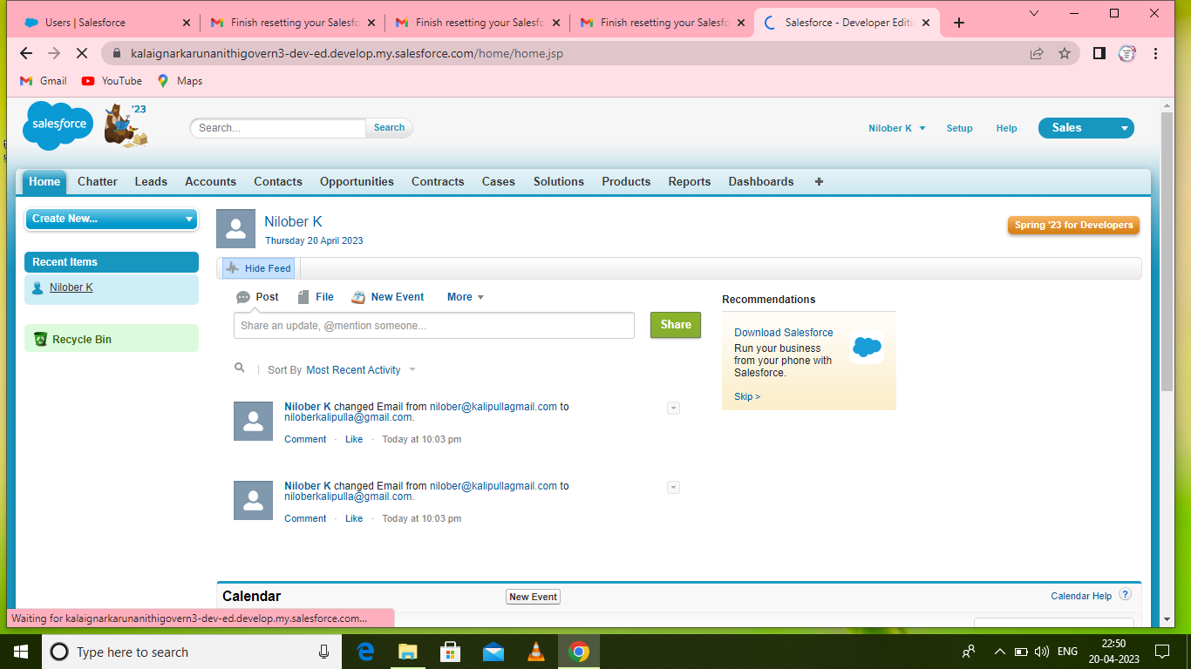

**Milestone 5 : Reports**

A report is a list of records that meet the criteria you define. It's displayed in Salesforce in

rows and columns, and can be filtered, grouped, or displayed in a graphical chart. Every

report is stored in a folder. Folders can be public, hidden, or shared, and can be set to

read-only or read/write.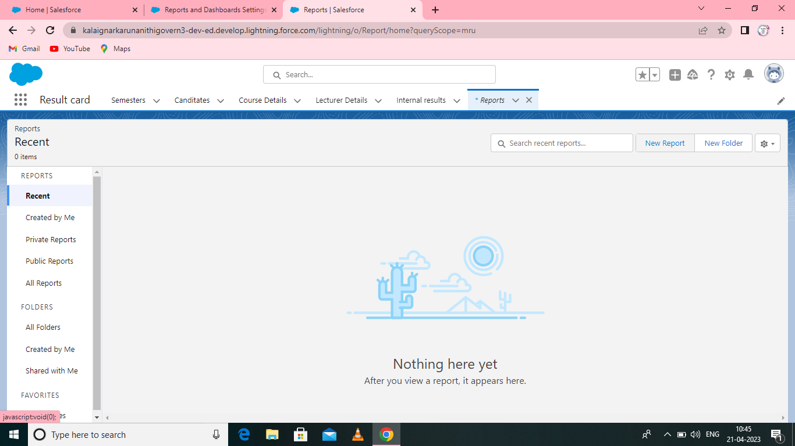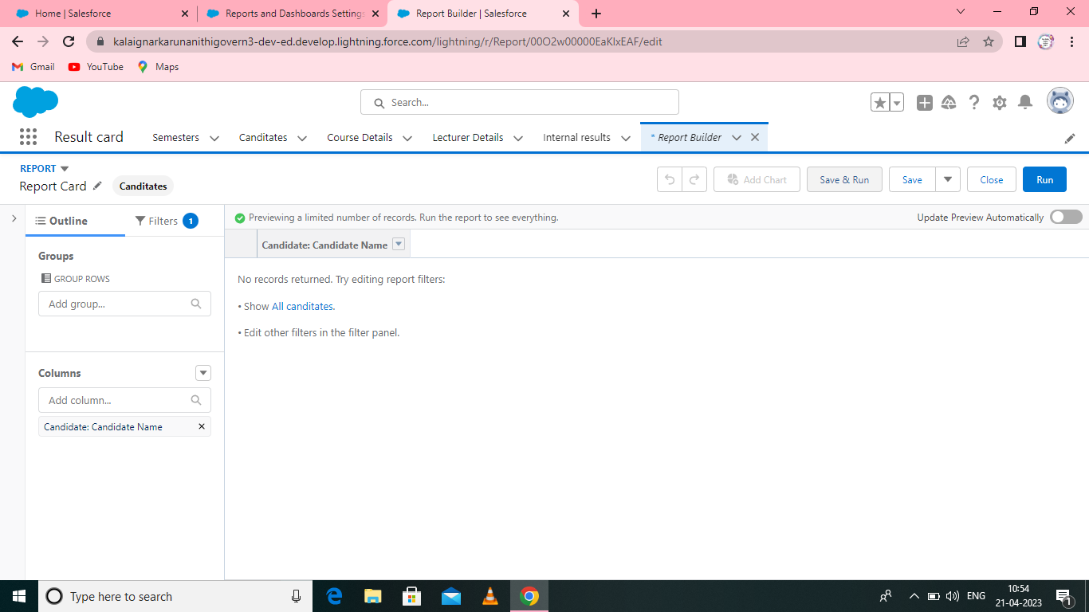

**Activity 1:**

To create a report:

Go to the app → click on the reports tab. 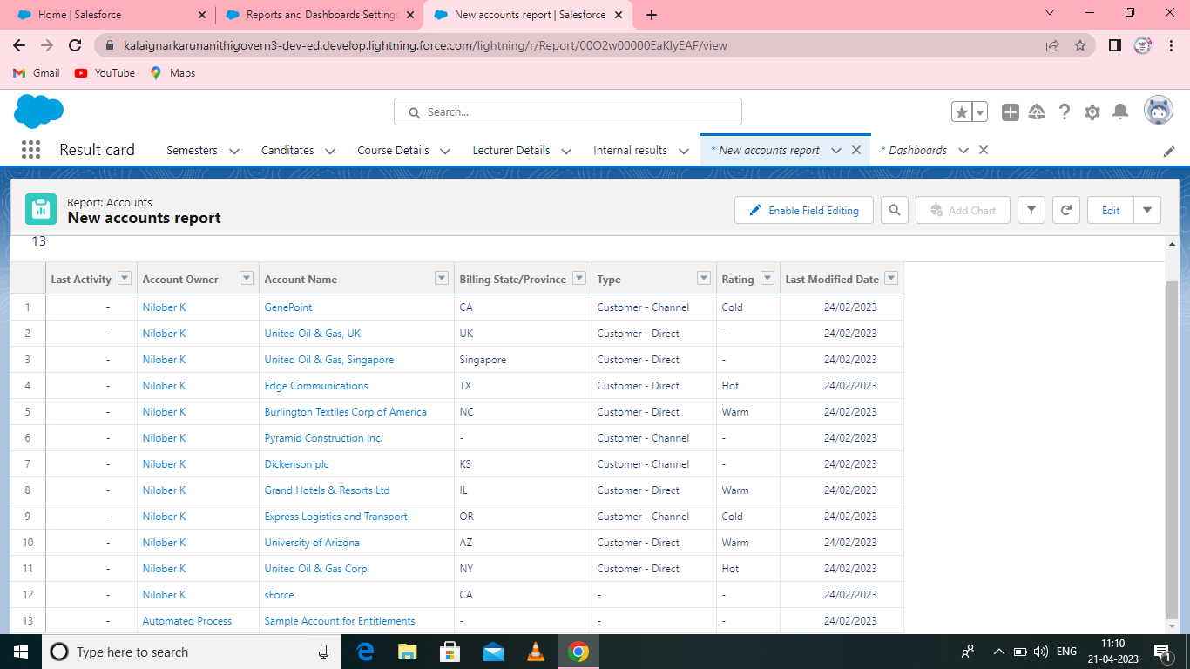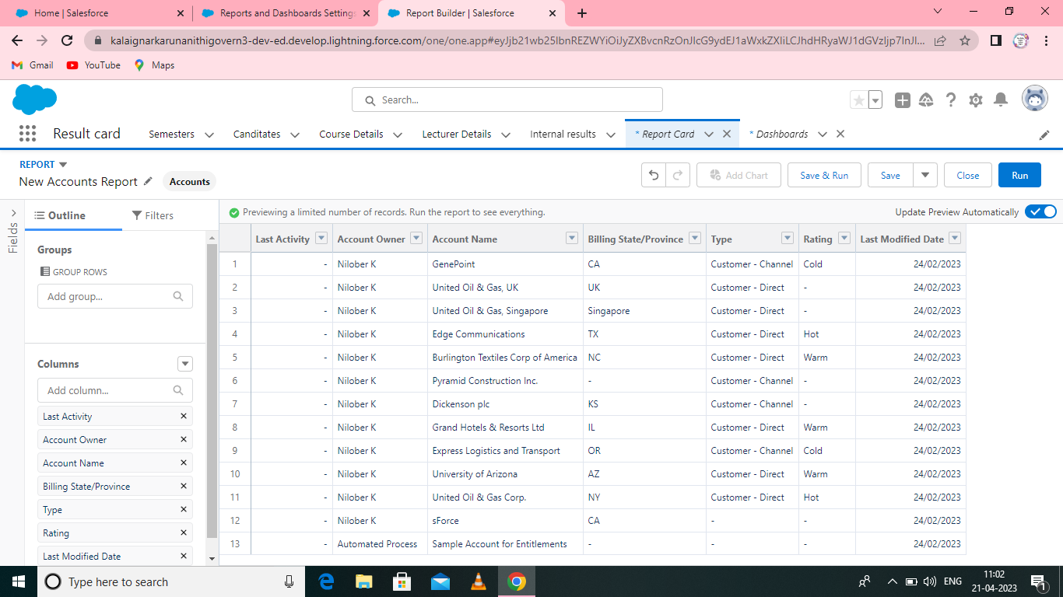

Customize your report, then save or run it.

**Milestone 6 : Dashboards:**

Dashboards let you curate data from reports using charts, tables, and metrics**.**

If your colleagues need more information, then they're able to view your

dashboard's data-supplying reports. Dashboard filters make it easy for users

to apply different data perspectives to a single dashboard.

**Activity 1:**

**Create a Dashboard:**

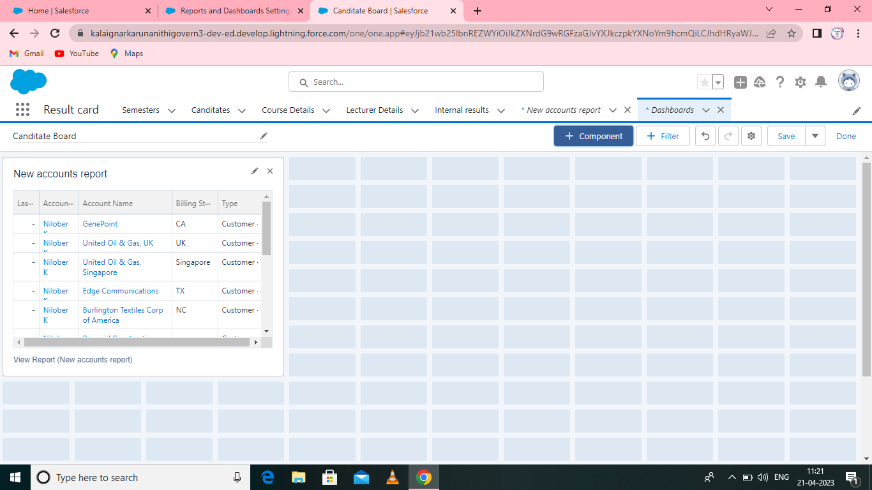

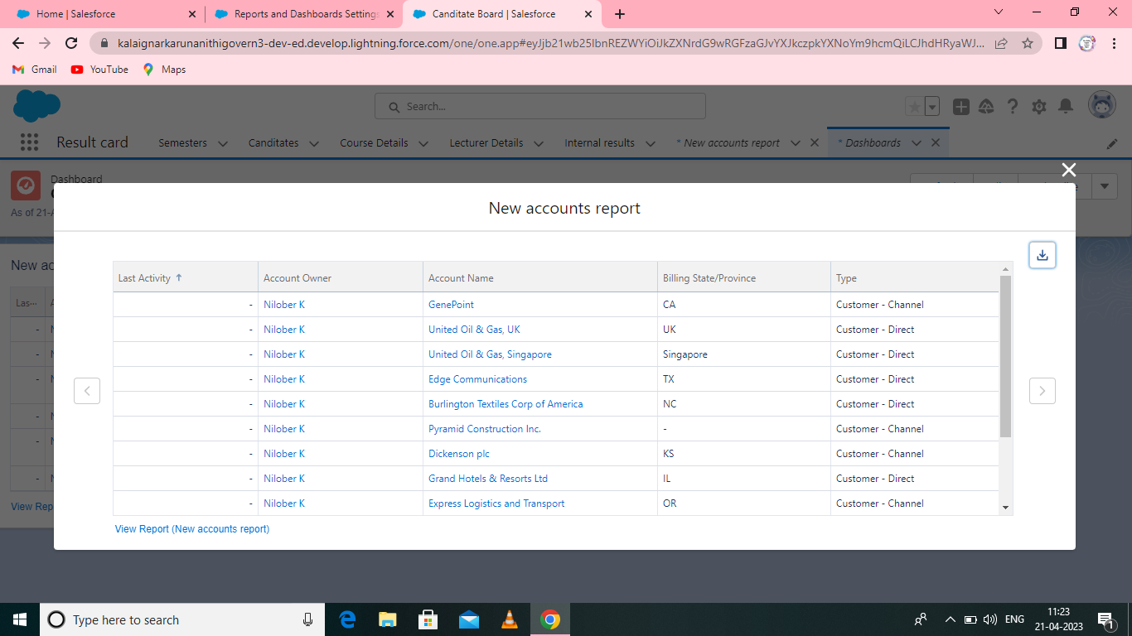

Click the Dashboards tab.

Click New Dashboard. Name your dashboard Candidate Board . Leave all other fields as is and click Create. Click + Component. For Report, select Candidate Marks by Stage. Click Select. For Display As, select Vertical Bar Chart and click Add. Click Save. Click Done.

**4 TrailheadProfilePublicURL**

**Team Lead –** [**https://trailblazer.me/id/nemsh-1**](https://trailblazer.me/id/nemsh-1)

**Team Member1-** [**https://trailblazer.me/id/maha0715**](https://trailblazer.me/id/maha0715)

**Team Member2-** [**https://trailblazer.me/id/maher86**](https://trailblazer.me/id/maher86)

**Team Member3-** [**https://trailblazer.me/id/snisha03**](https://trailblazer.me/id/snisha03)

**5 ADVANTAGES**

* It allows for the consolidation of customer data and the basis for deep insights.

*It speeds up the sales conversion process.

*It increases staff productivity, lowering time -cost .

*It allows geographically dispersed teams to collaborate effectively.

*Improves customer experience by allowing personalization and improved query resolution**.**

**DISADVANTAGES**

*Customer experience may worsen due to staff over-reliance on the system.

* Security and data protection issues with centralized data.

*The excess initial time and productivity cost at the implementation.

* Requires a process driven sales organization -CRM may not suit all business.

**6 APPLICATION:**

• In schools, college even in universities, it would be very useful in monitoring students performance and records.

• Increase candidate quality.

• Can work easily.

• Streamlining internal sales processes.

• I want something reliable.

**7 CONCLUSION:**

Student Internal Mark

Management System deals with student details, academic related reports,college details and course details. It tracks all the details of a student from the day one to the end of his course which can be used for all reporting purpose, tracking of progress in the course ,completed semester, upcoming semester details, exam details,project or any other assignment details,and final exam result.

**8 FUTURE SCOPE:**

CRM systems might imply automation, but many only offer baseline automation options. The future of CRM will include users who demand more functionality. They'll be looking for providers that cover typical CRM essentials as well asmore sophisticated automation.

The scope of CRM includes a wide range of activities, from managing customer contact information to developing personalized marketing campaigns.